**KB728: Small Enough Computer Keyboard**

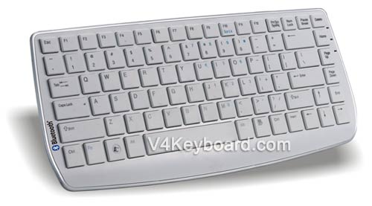

KB728 is our new keyboard which is under developping. There are no edit area and numeric area. It’s easy for KB728 to be small enough

## Mini Computer Keyboard with Shrunk Keys

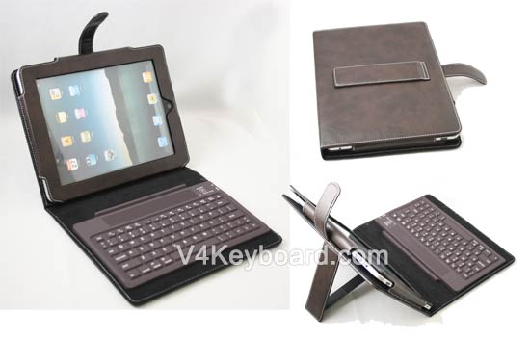

If you think KB728 is not small enough. The only way to meet your target is choose those keyboards which use shrunk and mini keys. For instance, the latest silicone keyboard which we’re preparing for iPad leather case.

## White Computer Keyboard BK6110

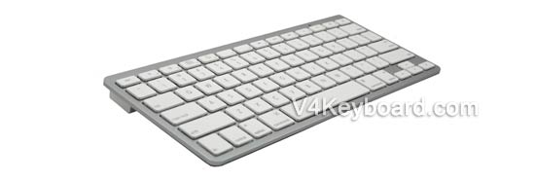

[BK6110](http://www.v4keyboard.com/portable-bluetooth-keyboard-bk6110) is our latest keyboard with apple-style appearance, and scissors keys. Excellent quality and competitive price. BK6110 is still a bluetooth keyboard now, we’ll launch wired keyboard, and rf wireless keyboard later.

## Bluetooth Laser Virtual Keyboard

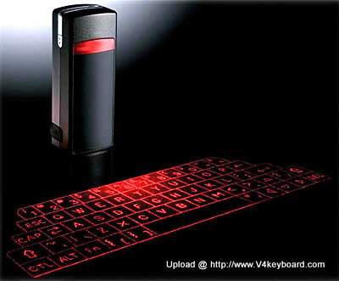

We didn’t find out its brand and manufacturers, let’s just call it bluetooth laser keyboard. It’s another laser computer keyboard, and its dimensions approximately is 35*92*25 mm. It’s connected by bluetooth v1.1 class 2. Project 295*95 mm virtual keyboard. Full size and QWERT layout. Another choice for people who want to write email anywhere.

# [Flexible Mini Keyboard](http://www.v4keyboard.com/flexible-mini-keyboard-directly-from-shenzhen-1344.html) Flexible mini keyboards in sevral colors.

Shenzhen V4 Electronic Co., Ltd. can supply you with good **flexible mini keyboard** at a competitive price and superior quality. Mini keyboard has been one of our main products in the recent years. The advantages of the flexible mini keyboard are their flexibility and convenience